**Total expense - 21984**

1. 300W 20A step down - tronic – (1200) - <https://tronic.lk/product/20a-300w-dc-to-dc-step-down-buck-adjustable-constant-vo>

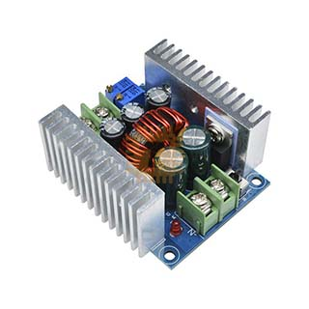

1. Wires type -1- (2000)
   1. Current limit 20A - 30A
   2. Silicon wires prefer
   3. Color Black and Red
   4. 3m each
2. Wires type -2 – (500)
   1. Larger than jumpers
   2. Color multiple
   3. 1m each
3. Jumpers – (300)
   1. Male to female
   2. Male to male
   3. Female to female
4. Breadboard – (500)
   1. Mini - <https://tronic.lk/product/170tp-black-mini-project-board-breadboard-solderless-45>
   2. Medium - <https://tronic.lk/product/mb-102-830tp-project-board-breadboard-solderless>
5. Terminal wire connecter 1:2 – (200)
   1. 15

1. Connecters – (200)
   1. **10**

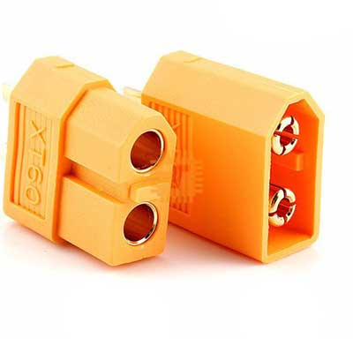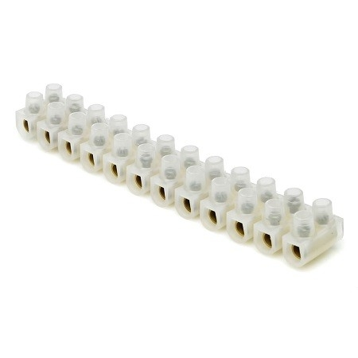

1. Cooling fan –(800)- <https://www.duino.lk/product/40x40x10mm-dc-24v-brushless-9-blade-cooling-fan-4010/>

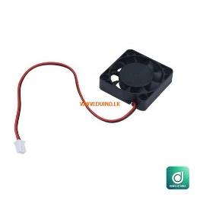

1. Jst connecters – from nisala –(NA)

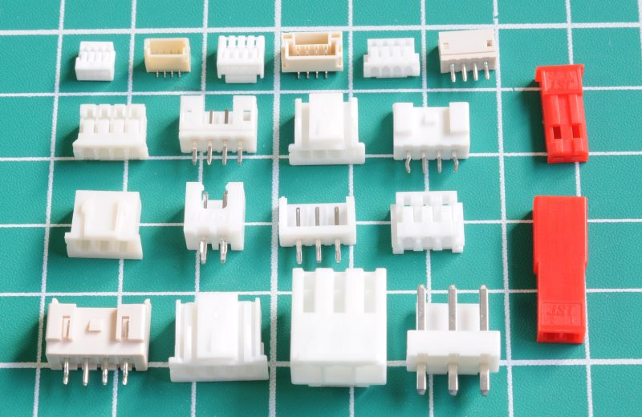

1. Heat shrink – (150)
   1. 1.5 m each
   2. For jumper size, 30 A wire, medium size wire   
      A group of black tubes

      Description automatically generated
2. 3 relay modules (30A,5V logic,normally off) – (500)

1. Nuts and bolts - 10 – (500)
2. Wire clips (50) for all wires. (need to direct jumper and jst cables as well)- (300)

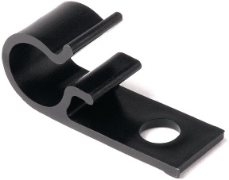

1. Dock station connecter – (1000)
2. Leds for dock station
3. Couper plates as connecters of dock station
4. Capacitor holders without usage of a PCB – (300)
5. Filament 1kg peach - (5000)

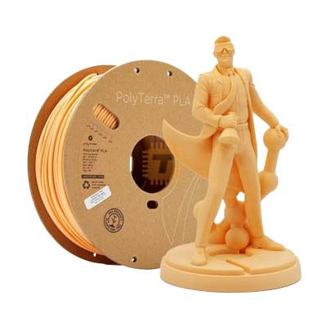

1. Spray paint (1500) – black (depend)
2. Revert for casters
3. Nuts and bolts for casters (additionally for the reverts)
4. Aluminum
   1. 20 cm width
   2. 200 cm length
   3. Lower than 1 mm
5. [6000-2RS 6000RS 6000 deep groove ball bearing 10x26x8 mm 10*26*8](https://vi.aliexpress.com/item/32497781206.html?gad_source=1&dp=2d8ed102354641f8f0d3b6e60d41cc43&af=983490&cv=47843&afref=https%3A%2F%2Fwww.google.com%2F&mall_affr=pr3&utm_source=admitad&utm_medium=cpa&utm_campaign=983490&utm_content=47843&dp=2d8ed102354641f8f0d3b6e60d41cc43&af=983490&cv=47843&afref=https%3A%2F%2Fwww.google.com%2F&mall_affr=pr3&utm_source=admitad&utm_medium=cpa&utm_campaign=983490&utm_content=47843&aff_fcid=dde1ad670a204d528cd55b99c1862b4e-1734532534838-07333-_ePNSNV&aff_fsk=_ePNSNV&aff_platform=portals-tool&sk=_ePNSNV&aff_trace_key=dde1ad670a204d528cd55b99c1862b4e-1734532534838-07333-_ePNSNV&terminal_id=47cb1123a4b0413c825f2102998930d4&afSmartRedirect=y&gatewayAdapt=glo2vnm)
6. 16 channel motor driver
7. A group of different colored terminals

   Description automatically generatedSade connecters

